Coman Diana 343C5, lab 1

TASK 1

student@uso:~/Desktop/lab1$ vmstat -d | sort -nr -k 2
sda 178257 22558 9818402 4633524 95147 235258 34666256 15906656 0 1661
loop8 25241 0 54484 165996 0 0 0 0 0 5
loop7 10448 0 24976 63552 0 0 0 0 0 2
loop15 1181 0 3554 1552 0 0 0 0 0 0
loop6 989 0 6040 3648 0 0 0 0 0 0
loop1 841 0 2868 3072 0 0 0 0 0 0
loop16 797 0 5630 2128 0 0 0 0 0 0
loop14 763 0 5574 2360 0 0 0 0 0 0
loop2 546 0 5164 3248 0 0 0 0 0 0
loop9 507 0 2206 860 0 0 0 0 0 0
loop4 120 0 1432 1188 0 0 0 0 0 0
loop12 117 0 534 1648 0 0 0 0 0 0
loop0 111 0 1414 1404 0 0 0 0 0 0
loop5 93 0 498 1520 0 0 0 0 0 0
loop11 81 0 462 584 0 0 0 0 0 0
loop13 76 0 1328 1064 0 0 0 0 0 0
loop3 71 0 454 2076 0 0 0 0 0 0
loop10 38 0 184 736 0 0 0 0 0 0
sr0 0 0 0 0 0 0 0 0 0 0
disk- ------------reads------------ ------------writes----------- -----IO------
total merged sectors ms total merged sectors ms cur sec

TASK 2
student@uso:~/Desktop/lab1$ taskset -c $((seq 1 2 $(nproc)) | tr '\n', ','| sed 's/.$//') ./fact_rcrs.py 10000
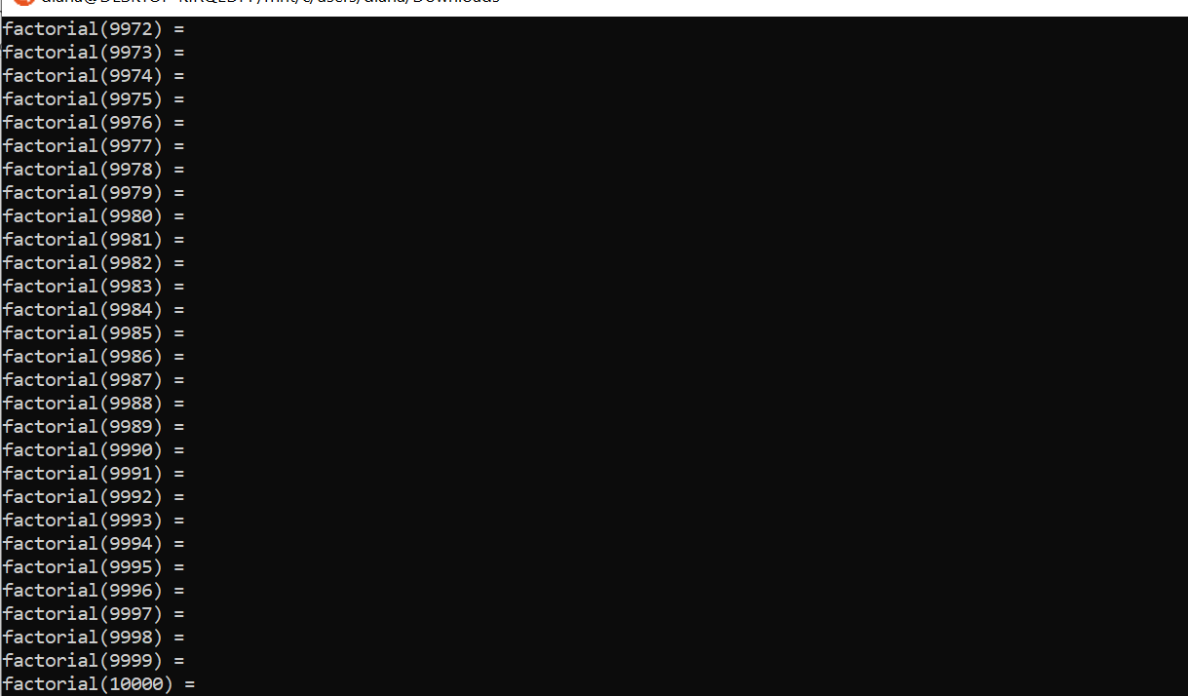
TASK 3
student@uso:~/Desktop/lab1$ for ((i = 0; i<10;i++)); do time zip -${i} -r ray-${i}.zip RAY.BMP 1>/dev/null; done

real 0m0,176s
user 0m0,000s
sys 0m0,007s

real 0m0,020s
user 0m0,015s
sys 0m0,004s

real 0m0,048s
user 0m0,024s
sys 0m0,000s

real 0m0,071s
user 0m0,033s
sys 0m0,000s

real 0m0,056s
user 0m0,028s
sys 0m0,000s

real 0m0,108s
user 0m0,043s
sys 0m0,000s

real 0m0,168s
user 0m0,070s
sys 0m0,000s

real 0m0,211s
user 0m0,103s
sys 0m0,000s

real 0m0,488s
user 0m0,191s
sys 0m0,000s

real 0m0,382s
user 0m0,208s
sys 0m0,000s

student@uso:~/Desktop/lab1$ ls -l
total 15632
-rw-rw-r-- 1 student student 4264316 oct 19 20:17 MARBLES.BMP
-rw-rw-r-- 1 student student 1440054 oct 19 20:18 RAY.BMP
-rw-rw-r-- 1 student student 6488666 oct 19 20:17 big.txt
-rwxr-xr-x 1 student student 353 oct 20 10:33 fact_rcrs.py
drwxr-xr-x 2 student student 4096 iul 26 06:20 hw_counter
-rwxr-xr-x 1 student student 869 oct 20 11:17 plot.py
-rw-r--r-- 1 student student 1440218 oct 20 11:20 ray-0.zip
-rw-r--r-- 1 student student 331253 oct 20 11:20 ray-1.zip
-rw-r--r-- 1 student student 310248 oct 20 11:20 ray-2.zip
-rw-r--r-- 1 student student 285757 oct 20 11:20 ray-3.zip
-rw-r--r-- 1 student student 255569 oct 20 11:20 ray-4.zip
-rw-r--r-- 1 student student 240879 oct 20 11:20 ray-5.zip
-rw-r--r-- 1 student student 231742 oct 20 11:20 ray-6.zip
-rw-r--r-- 1 student student 229192 oct 20 11:20 ray-7.zip
-rw-r--r-- 1 student student 227524 oct 20 11:20 ray-8.zip
-rw-r--r-- 1 student student 227390 oct 20 11:20 ray-9.zip

Am bagat datele acolo in plot.py si l –am rulat
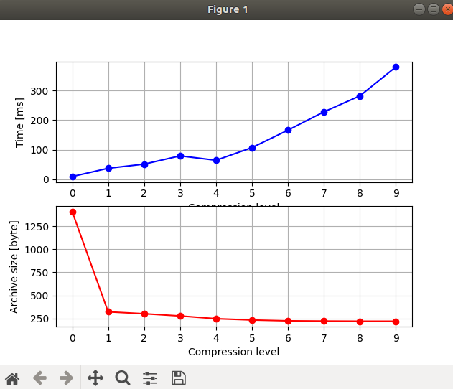

TASK 4

Nu am linux nativ, nu mi-a mers pe masina virtuala sau pe subsistem sa fac taskul

Acesta este codul scris, insa nu il pot rula

/* TODO: count L2 cache misses for the next block using RDPMC */
rdpmc(ecx, eax, edx);
counter = ((uint64_t) eax) | (((uint64_t) edx) << 32);

/* perform slow multiplication */
for (uint32_t i=0; i<N; ++i) /* line */
for (uint32_t j=0; j<N; ++j) /* column */
for (uint32_t k=0; k<N; ++k)
r[i*N + j] += m1[i*N + k] * m2[k*N + j];
rdpmc(ecx, eax, edx);
counter = (((uint64_t) eax) | (((uint64_t) edx) << 32)) - counter;

/* TODO: count L2 cache misses for the next block using RDPMC */
rdpmc(ecx, eax, edx);
counter = ((uint64_t) eax) | (((uint64_t) edx) << 32);

/* perform fast(er) multiplication */
for (uint32_t k=0; k<N; ++k)
for (uint32_t i=0; i<N; ++i) /* line */
for (uint32_t j=0; j<N; ++j) /* column */
r[i*N + j] += m1[i*N + k] * m2[k*N + j];
rdpmc(ecx, eax, edx);
counter = (((uint64_t) eax) | (((uint64_t) edx) << 32)) - counter;

TASK 5


